Module 4 — Assignment 1 — API Testing

Objective
Create a Postman collection that authenticates a user, stores the authentication token, calls three dependent APIs using that token/context, validates each response, and generates a collection report. Environment variables are used throughout.

Environment Setup
An environment named "Test Env" was created with a single variable, auth_token (value populated at runtime). This environment was selected as the active environment before running any request.

Collection: "API Testing Flow"

Request 1 — Authenticate User
- Method: GET
- URL: https://jsonplaceholder.typicode.com/users/1
Since the demo API has no real login endpoint, this call simulates authentication by fetching the user record; a token-like value is then generated and stored, reproducing the pattern of a real login step.
pm.test("Request successful", () => pm.response.to.have.status(200));
const fakeToken = "demo-token-" + pm.response.json().id;
pm.collectionVariables.set("auth_token", fakeToken);
Purpose: Authenticates the user and stores the resulting token in the auth_token collection variable for reuse by later requests.

Request 2 — Dependent API: Get Posts by User
- Method: GET
- URL: https://jsonplaceholder.typicode.com/posts?userId=1
pm.test("Status 200", () => pm.response.to.have.status(200));
Purpose: Retrieves all posts belonging to the authenticated user, using {{auth_token}} where an Authorization header would be required against a real secured API.

Request 3 — Dependent API: Get Todos by User
- Method: GET
- URL: https://jsonplaceholder.typicode.com/todos?userId=1
pm.test("Status 200", () => pm.response.to.have.status(200));
Purpose: Retrieves the authenticated user's todo items, validating a second dependent resource.

Request 4 — Dependent API: Get Albums by User
- Method: GET
- URL: https://jsonplaceholder.typicode.com/albums?userId=1
pm.test("Status 200", () => pm.response.to.have.status(200));
Purpose: Retrieves the authenticated user's albums, completing the third dependent API call.

Validation Summary
Each of the four requests includes an automated test asserting a 200 OK status, confirming the request executed and the dependent resource was returned successfully in the context established by Request 1.

Collection Report
The full collection was executed using the Postman Collection Runner with "Test Env" active. The run summary shows all 4 requests executed in order with all assertions passing.
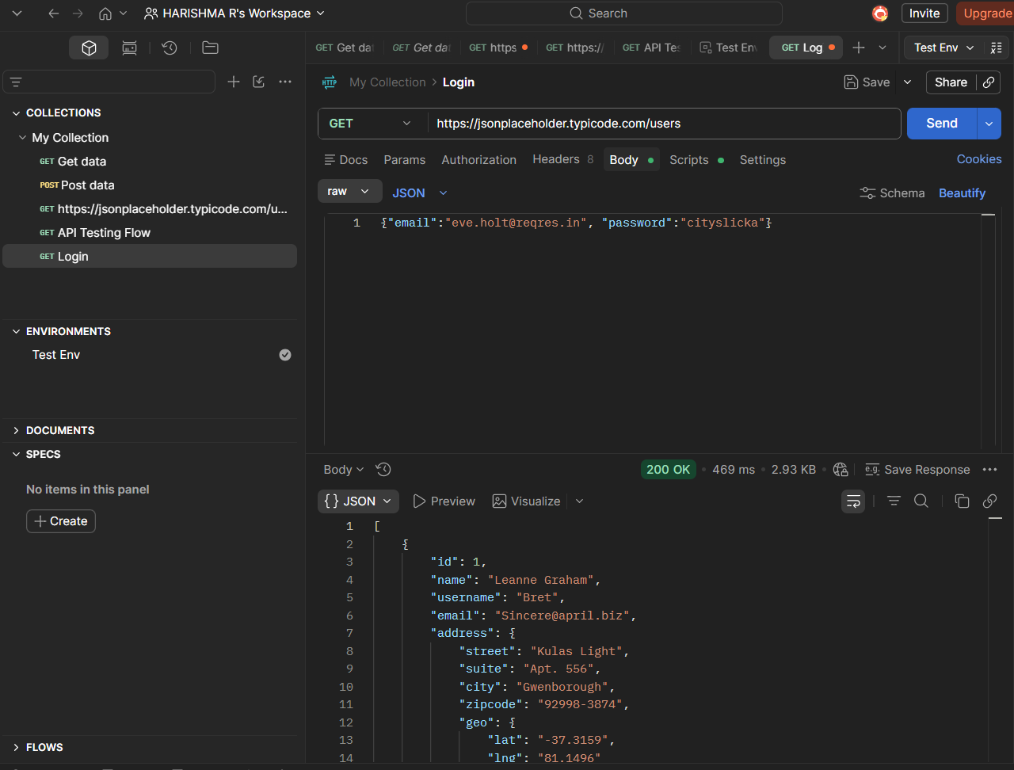

Assignment 6 — API Request Design

Scenario
A REST API is available to retrieve all connected resources. In the absence of a provided endpoint, the public jsonplaceholder API was used, with GET /users representing the equivalent of GET /api/accesspoints for the purpose of this exercise.

HTTP Method
GET

Request URL
https://jsonplaceholder.typicode.com/users

Expected Status Code
200 OK

Expected Response Format
application/json — a JSON array, where each element is an object representing one resource (e.g. id, name, email, address fields for a user).

Three Validations
pm.test("Status code is 200", () => pm.response.to.have.status(200));
pm.test("Response is JSON", () => pm.response.to.be.json);
pm.test("Response is an array", () => pm.expect(pm.response.json()).to.be.an("array"));
Result: All three tests passed (visible under the Test Results tab after sending the request).

Postman Query Screenshot
